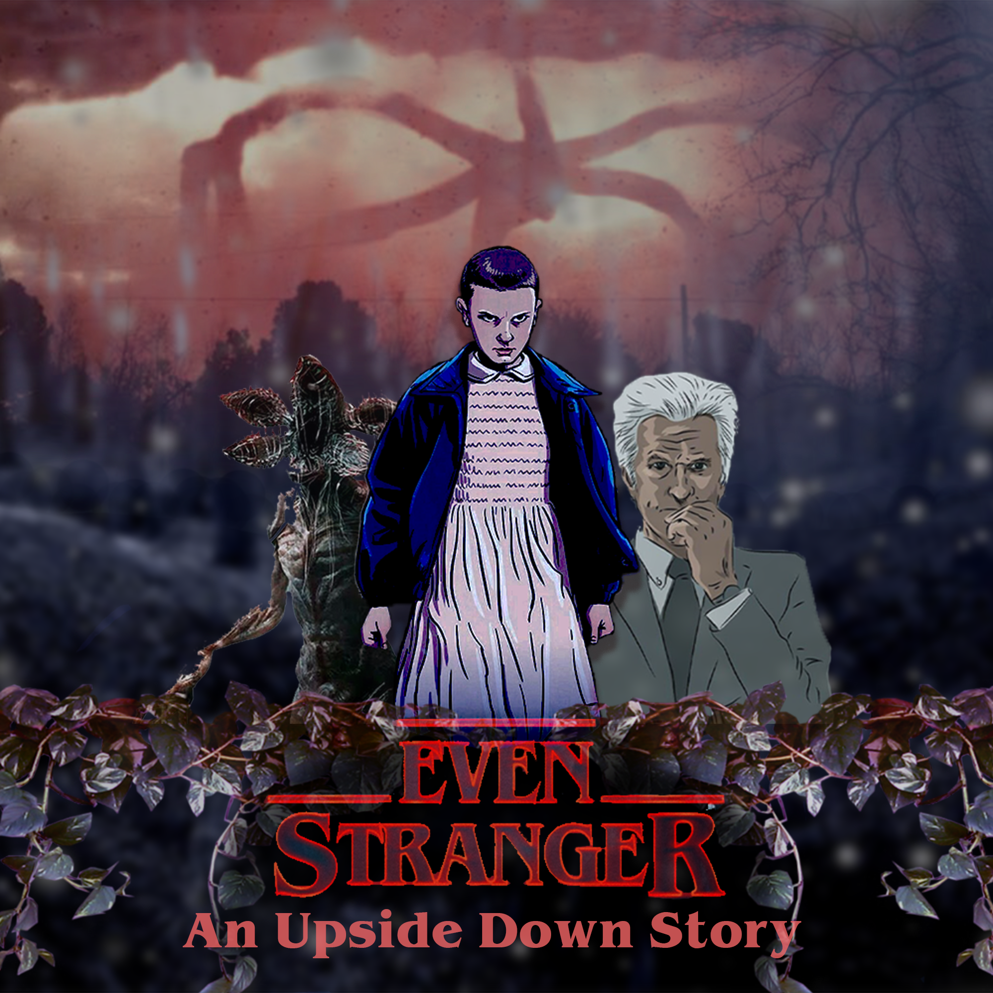

Data Management Document

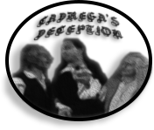

**Cadrega’s Deception Team:**

Davide Bagnato - 957844 - [davide.bagnato@studenti.unimi.it](mailto:davide.bagnato@studenti.unimi.it)

Federico Porteri - 945812 -

[federico.porteri@studenti.unimi.it](mailto:federico.porteri@studenti.unimi.it)

Angelo Maurizio Alfano - 945769 -

[angelomaurizio.alfano@studenti.unimi.it](mailto:angelomaurizio.alfano@studenti.unimi.it)

## INDEX

**Revision History** **2**

**Software list** **3**

**Organization software** **3**

**Environments** **4**

**Data types and formats** **4**

**Data storage and Backup Policies** **6**

**Naming conventions** **7**

**Directory structure**8

## 

## Revision History

|  |  |  |
| --- | --- | --- |
| **What** | **When** | **Who** |
| Document creation | 25/11/2019 | Federico |
| Document building | 25/11/2019 | Federico |
| Document additions | 26/11/2019 | Davide |
| Document revision | 12/12/2019 | Federico |
| Document additions | 11/01/2019 | Angelo |
| Statsblocks, Tiled, Audio | 14/01/2019 | Angelo |
| Backup Policies (Updated) | 15/01/2019 | Davide |
| Name conventions | 17/01/2019 | Davide |
| Directory structure | 18/01/2019 | Davide |
| Github policy update | 18/01/2019 | Davide |
| Final check | 18/01/2019 | Davide, Federico, Angelo |

## 

## Software list

## This document explains the list of software used to create all the documentation about “Even stranger: an Upside Down story” made by the group Cadrega’s Deception. Softwares, versions, naming conventions and backup policies must be respected by all the users.

**Asset editing software**

|  |  |  |
| --- | --- | --- |
| **SW name** | **Version** | **Platform** |
| Adobe Photoshop CC 2019  <https://www.adobe.com/it/products/photoshop.html> | 20.0.3 | Windows |
| Draw.io  ([http://draw.io](http://www.draw.io)) | Online | Online |
| Google Docs  ([https://docs.google.com](http://www.docs.google.com)) | Online | Online |
| D&D 5e Statblock Generator (<https://tetra-cube.com/dnd/dnd-statblock.html>) | Online | Online |
| Tiled Map Editor  ([https://mapeditor.org/](https://www.mapeditor.org/)) | 1.3.1 | Windows |

## Organization software

|  |  |  |
| --- | --- | --- |
| **SW name** | **Version** | **Platform** |
| Google Drive  <http://drive.google.com/> | Online | Online |
| Backup and Sync from Google  <https://www.google.com/drive/download/backup-and-sync/> | 3.47 | Windows |
| Git SCM  <https://git-scm.com/downloads> | 2.24.1.windows.2 | Windows |
| GitHub  <https://github.com/> | Online | Online |

## Prototyping software

RPG Maker 1.5.1 (Base assets pack) <https://www.rpgmakerweb.com/products/programs/rpg-maker-mv>

## Environments

## Microsoft Windows 10 Pro

## Data types and formats

Text

The documentation containing text must be in **.gdoc** and may contain images. The final version of every document must be saved in **.pdf**. The final version must contain the header and the footer with the UNIMI logo.

Gdoc Font:

Main text font - *Montserrat*

Characters and Enemies font - *Comfortaa*

Story Screenplays font - *Roboto mono*

Allignment:

Justified (Main text)

Centered (Images description)

## Sounds

Sounds must be in **.WAV 44.1 kHz** or **.MP3** **256 kbit/s.**

## Images

|  |  |  |
| --- | --- | --- |
| **Type** | **Format** | **Max size** |
| Illustrations | png / jpeg and PSD | 300 dpi, 2000x2000 |
| Icons | png / jpeg and PSD | 72 dpi, 300x300 |
| Logos | png / jpeg and PSD | 72 dpi, 300X160 |
| Monster Stats | png and monster | 150 dpi, 400X600 |

Edited images projects are stored in Photoshop **.PSD** format.

All Monster Statblock must be also saved in the **.monster** (unique to the “D&D 5e Statblock Generator“ website) format.

## Diagrams and Flowcharts

To create a diagram the user must use *Draw.io (*[*www.draw.io*](http://www.draw.io)*) (Online)* and export it in addition to save it as a **.*drawio*** file and **.png** image.

Diagrams include Enemies state diagrams, Level and Story flowcharts, Skills diagrams and Paths (on the plants).

To make further additions **Photoshop** (**.psd**) has been used too.

## Plants and Battlefields

*Tiled* projects to make plants use **.TMX** and can be saved as **.png** files.

For battlefields TMX files are given for the fixed position ones only.

Single tiles use **.tsx** extension. To make further additions **Photoshop** (**.psd**) has been used too.

## Prototyping types and formats

RPG Maker MV projects are stored in specific project folders.

An example of an RPG maker MV folder:

* <project name>
  + <audio>
  + <data>
  + <fonts>
  + <icon>
  + <img>
  + <js>
  + <movies>

Game.rpgproject(Project file, extension is **.rpgproject**)

index.html

For more informations about the content of these folders please see RPG Maker MV Documentation.

## **Data storage** and Backup Policies

Backup manager: Davide Bagnato.

All the documentation must be saved on **Google Drive** since multiple users can work on different part of the same document and it is directly linked to Google Docs. Every time a document is updated or changed in any way, it must be written in the revision history with the subject, the data of the change and the name of the user.

The same project folder stored on Google Drive is also stored and updated on a private **Git repository.**

The repository is managed through **GitHub** and Git for Windows (Git Bash).

To use the same folder as repository and update it automatically on Google Drive we used **Backup and Sync from Google**.

To keep track of the versioning more accurately and for a longer period, every time a modification is made, at the end of the day the project must be *committed* and *pushed* on the repository too.

Google Drive in fact keeps tracks of every change made to a document in the last 30 days only.

Every Sunday a backup is saved on an external hard drive too.

Google Drive Folder:

<https://drive.google.com/drive/folders/1rGV3bN--Oxax6MMm1diybQiPeDe1DmAH>

Github: <https://github.com/davidebug/EvenStrangerCD/>

Owner: Davide Bagnato (Github name: davidebug).

## Naming conventions

<value> → Insert the value given between the angle brackets (using camel case).

|  |  |  |
| --- | --- | --- |
| **Type** | **Naming convention** | **Example** |
| Text (Dialogues) | Level<levelNumber>_Dialogues.gdoc | Level6_Dialogues.gdoc |
| Text (Screenplays) | Level<levelNumber>_Screenplay.gdoc | Level6_Screenplay.gdoc |
| Logos | <Title>_Logo.png/ psd | CadregasDeception_Logo.png |
| Covers | <Title>_Cover.png /psd | EvenStranger_Cover.png |
| Stats (Images and Monster files) | <Name>_Stats.png / monster | Demodog_Stats.png |
| Plants | Level<levelNumber>_<Subarea name>_Plant.png / tmx / psd | Level6_surroundingForest_Plant.png |
| Paths | Level<levelNumber>_<Subarea name>_Paths.png / drawio / psd | Level6_surroundingForest_Paths.png |
| Battlefields | Level<levelNumber>_BT<BattleNumber>_BF.png/ tmx | Level6_BT6.2.1_BF.png/ tmx |
| Tilesets (Tiled) | <tilesetContent>_Tileset.png/ tsx | Chair_Tileset.png |
| Symbols (Paths) | <symbolName>_PathsSymbols.png | MainInteraction_PathsSymbols.png |
| Table of Storytelling elements | <nameOfTheElement>_TableOfStorytelling.png | Mad_TableOfStorytelling.png |
| Skills Diagrams | <nameOfSkilltree>_SkillDiagram.png / drawio | skillsComplete_SkillDiagram.png |
| Legends (Diagrams and Flowcharts) | <nameOfDiagram/Flowchart>_Legend.png / drawio | CompleteStoryFlowchart_Legend.png |
| Flowcharts (Story) | <nameOfFlowchart>_Flowchart.png / drawio | CompleteStoryFlowchart_Flowchart.png |
| Flowcharts(Levels) | Level<levelNumber>_<subareaName>_Flowchart.png/ drawio | Level6_WillsGarden_Flowchart.png |
| Diagrams | Level<levelNumber>_<subareaName>_Diagram.png | Level6_Complete_Diagram.png |
| Maps of relationship | <Character>_MapOfRelationship.png | Mikey_MapOfRelationship.png |
| Circumplexes | <Character>_Circumplex.png | Mikey_Circumplex.png |
| Enemies State diagrams | <Enemy>_StateDiagram.png / drawio | Demodorgon_StateDiagram.png |
| Concepts | <Name>_Concept[<Autor>].png | Demodorgon_Concept[cinemaMind].png |
| Samples | <Name>_SampleImage.png | HealingRoot_SampleImage.png |
| Palettes | Level<levelNumber>_<subareaName>_Palette.png | Level6_WillsGarden_Palette.png |
| Audio (Ambience) | <Name>_AmbienceAudio.wav /mp3 | WillsHouseNoises_AmbienceAudio.wav |
| Audio (Sound Effects) | <Name>_SoundEffect.wav /mp3 | WillsHouseFloor_SoundEffect.wav |
| Audio (Music) | <Name>_Music.wav / mp3 | TheDemodorgon_Music.wav |
| Folder | <Content> | EnemiesStateDiagrams |

## Directory structure

Directory structure with current files needed for the Level Design Document (18/01/2020).

───GLD_EvenStranger_CadregasDeception

├───Documentation

│ │ DMD_EvenStranger_CadregasDeception.gdoc

│ │ LDD_EvenStranger_CadregasDeception.gdoc

│ │

│ ├───CoverAndTeamLogo

│ │ CadregasDeception_Logo.png

│ │ CadregasDeception_Logo.psd

│ │ EvenStranger_Cover.png

│ │

│ ├───GameDesign

│ │ ├───Concepts

│ │ │ │ Abilities_SampleImage.png

│ │ │ │ bannerSaga_SampleImage.png

│ │ │ │ bathroom_SampleImage.jpg

│ │ │ │ Byershouse_SampleImage.jpg

│ │ │ │ catnipDemonBVial_Concept[UA].png

│ │ │ │ Combat_SampleImage.png

│ │ │ │ elevenArmor_SampleImage.png

│ │ │ │ firstAidKit_Concept[UA].png

│ │ │ │ healingRoot_Concept[UA].png

│ │ │ │ HouseInternals_SampleImage.jpg

│ │ │ │ hudExample_SampleImage.png

│ │ │ │ LetterWall_SampleImage.png

│ │ │ │ LetterWall__SampleImage.png

│ │ │ │ lightWall_SampleImage.png

│ │ │ │ MapProject_SampleImage.psd

│ │ │ │ Map_SampleImage.jpg

│ │ │ │ meditationRoot_Concept[UA].png

│ │ │ │ MindFlayerRoots_SampleImage.png

│ │ │ │ MovementExample_SampleImage.png

│ │ │ │ nimbleRoot_Concept[UA].png

│ │ │ │ rageRoot_Concept[UA].png

│ │ │ │ Shed_SampleImage.png

│ │ │ │ Shortcut_SampleImage.png

│ │ │ │ skillPoint_Concept[UA].png

│ │ │ │ SurroundingForest_SampleImage.jpg

│ │ │ │ tentaclesFire_SampleImage.jpg

│ │ │ │ willRifle_SampleImage.jpg

│ │ │ │ willsD_D_SampleImage.png

│ │ │ │ willsHouseMap_SampleImage.jpg

│ │ │ │ Forest_SampleImage.jpg

│ │ │ │ Forest2_SampleImage.jpg

│ │ │ │ Forest3_SampleImage.jpg

│ │ │ │ Forest4_SampleImage.jpg

│ │ │ │ Forest5_SampleImage.jpg

│ │ │ │ Forest6_SampleImage.jpg

│ │ │ │ Forest7_SampleImage.jpg

│ │ │ │ PoliceOffice_SampleImage.jpg

│ │ │ │ LabCorridor_SampleImage.jpg

│ │ │ │ Lab_SampleImage.jpg

│ │ │ │ HawkinsSchool_SampleImage.jpg

│ │ │ │ SchoolCorridor_SampleImage.jpg

│ │ │ │ Lake_SampleImage.jpg

│ │ │ │ House_SampleImage.jpg

│ │ │ │ LetterWall_SampleImage.jpg

│ │ │ │ SourceOfPower_SampleImage.jpg

│ │ │ │ Kitchen_SampleImage.jpg

│ │ │ │

│ │ │ ├───EnemiesConcepts

│ │ │ │ BroodMotherCocoon_Concept[ST].png

│ │ │ │ BroodMotherCocoon_Concept[ST].psd

│ │ │ │ BroodMother_Concept[cinemaMind].png

│ │ │ │ BroodMother_Concept[cinemaMind].psd

│ │ │ │ bulb_Concept[ResidentEvil2].jpg

│ │ │ │ catnipBulb_Concept[UA].jpg

│ │ │ │ catogorgon2_Concept[UA].jpg

│ │ │ │ Demodog_Concept[UA].png

│ │ │ │ Demodorgon_Concept[cinemaMind tumblr].jpg

│ │ │ │ Demodorgon_Concept[UA].png

│ │ │ │ demomole_Concept[LittleJerboa].png

│ │ │ │ frogorgon_Concept[ST].png

│ │ │ │ strangeCocoon_Concept[justGames Armenia].jpg

│ │ │ │ vinesTentacles2_Concept[NikoJPope].jpg

│ │ │ │ vines_Concept[ST].jpg

│ │ │ │

│ │ │ └───Palettes

│ │ │ Level6_house_Palette.png

│ │ │ Level6_shed_Palette.png

│ │ │ Level6_surroundingForerst_Palette.png

│ │ │ Level6_willsGarden_Palette.png

│ │ │

│ │ ├───SkillsDiagrams

│ │ │ skillsComplete_SkillDiagram.drawio

│ │ │ skillsComplete_SkillDiagram.png

│ │ │

│ │ ├───Stats&StateDiagrams

│ │ │ │ broodMother_Stats.monster

│ │ │ │ broodMother_Stats.png

│ │ │ │ bulb_Stats.monster

│ │ │ │ bulb_Stats.png

│ │ │ │ catnipBulb_Stats.monster

│ │ │ │ catnipBulb_Stats.png

│ │ │ │ catogorgon_Stats.monster

│ │ │ │ catogorgon_Stats.png

│ │ │ │ demodogAlpha_Stats.monster

│ │ │ │ demodogAlpha_Stats.png

│ │ │ │ demodog_Stats.monster

│ │ │ │ demodog_Stats.png

│ │ │ │ demodorgon.monster

│ │ │ │ demodorgon_Stats.png

│ │ │ │ demomole_Stats.monster

│ │ │ │ demomole_Stats.png

│ │ │ │ eleven_Stats.png

│ │ │ │ frogorgon_Stats.monster

│ │ │ │ frogorgon_Stats.png

│ │ │ │ mikey_Stats.monster

│ │ │ │ mikey_Stats.png

│ │ │ │ pollywog.monster

│ │ │ │ pollywog_Stats.png

│ │ │ │ slug_Stats.monster

│ │ │ │ slug_Stats.png

│ │ │ │ strangeCocoon_Stats.monster

│ │ │ │ strangeCocoon_Stats.png

│ │ │ │ vineTentacles_Stats.monster

│ │ │ │ vineTentacles_Stats.png

│ │ │ │

│ │ │ └───StateDiagrams

│ │ │ BroodMother_StateDiagram.drawio

│ │ │ BroodMother_StateDiagram.png

│ │ │ Bulb_StateDiagram.drawio

│ │ │ Bulb_StateDiagram.png

│ │ │ CatnipBulb_StateDiagram.drawio

│ │ │ CatnipBulb_StateDiagram.png

│ │ │ Catogorgon_StateDiagram.drawio

│ │ │ Catogorgon_StateDiagram.png

│ │ │ Demodog_StateDiagram.drawio

│ │ │ Demodog_StateDiagram.png

│ │ │ Demodorgon_StateDiagram.drawio

│ │ │ Demodorgon_StateDiagram.png

│ │ │ Demomole_StateDiagram.drawio

│ │ │ Demomole_StateDiagram.png

│ │ │ Frogorgon_StateDiagram.drawio

│ │ │ Frogorgon_StateDiagram.png

│ │ │ Pollywog_StateDiagram.drawio

│ │ │ Pollywog_StateDiagram.png

│ │ │ Slug_StateDiagram.drawio

│ │ │ Slug_StateDiagram.png

│ │ │ VineTentacles_StateDiagram.drawio

│ │ │ VineTentacles_StateDiagram.png

│ │ │

│ │ └───Story

│ │ │ StoryFlowchart_Flowchart.png

│ │ │ StoryFlowchart_Legend.png

│ │ │

│ │ ├───Circumplexes

│ │ │ Eleven_Circumplex.png

│ │ │ Father_Circumplex.png

│ │ │ Mikey_Circumplex.png

│ │ │ MindFlayer_Circumplex.png

│ │ │ Terry_Circumplex.png

│ │ │

│ │ ├───MapsOfRelationship

│ │ │ ElevenAfterReveal_MapOfRelationship.png

│ │ │ Eleven_MapOfRelationship.png

│ │ │ Father_MapOfRelationship.png

│ │ │ MikeyAfterReveal_MapOfRelationship.png

│ │ │ Mikey_MapOfRelationship.png

│ │ │ Mikey_MapOfRelationship.psd

│ │ │ MindFlayerAfterReveal_MapOfRelationship.png

│ │ │ MindFlayer_MapOfRelationship.png

│ │ │ Mother_MapOfRelationship.png

│ │ │

│ │ └───TableOfStorytelling

│ │ 3act_TableOfStorytelling.PNG

│ │ Ah_TableOfStorytelling.PNG

│ │ Bad__TableOfStorytelling.PNG

│ │ Bks_TableOfStorytelling.PNG

│ │ Chs_TableOfStorytelling.PNG

│ │ Dyn_TableOfStorytelling.PNG

│ │ Ewl_TableOfStorytelling.PNG

│ │ Fht_TableOfStorytelling.PNG

│ │ Hft_TableOfStorytelling.PNG

│ │ Mad_TableOfStorytelling.PNG

│ │ Mpb__TableOfStorytelling.PNG

│ │ Re_TableOfStorytelling.PNG

│ │

│ └───LevelDesign

│ ├───LevelDiagrams

│ │ Level6_Access_Diagram.png

│ │ Level6_Complete_Diagram.png

│ │ Level6_Complete_Diagram.psd

│ │ Level6CompleteDiagram_Legend.drawio

│ │ Level6_Access_DIagram.drawio

│ │ Level6_SurroundingForest_FlowChart.drawio

│ │ Level6_SurroundingForest_FlowChart.png

│ │ Level6_WillsGarden_Flowchart.drawio

│ │ Level6_WillsGarden_Flowchart.png

│ │ Level6_WillsHouse_FlowChart.drawio

│ │ Level6_WillsHouse_FlowChart.png

│ │ LevelFlowcharts_Legend.png

│ │ World_Diagram.png

│ │

│ └───PlantsPathsBattlefields

│ ├───Battlefields

│ │ Level6_BT6.1_BF.png

│ │ Level6_BT6.2.1_BF.png

│ │ Level6_BT6.2.1_BF.tmx

│ │ Level6_BT6.2.2_BF.png

│ │ Level6_BT6.2.2_BF.tmx

│ │ Level6_BT6.2.3_BF.png

│ │ Level6_BT6.2.4_BF.png

│ │ Level6_BT6.2.4_BF.tmx

│ │ Level6_BT6.2.5_BF.png

│ │ Level6_BT6.2.5_BF.tmx

│ │ Level6_BT6.2_BF_.png

│ │ Level6_BT6.3.1_BF.png

│ │ Level6_BT6.3.2_BF.png

│ │ Level6_BT6.3.3_BF.png

│ │ Level6_BT6.3.3_BF.tmx

│ │ Level6_BT6.3_BF.png

│ │ Level6_BT6.4_BF.png

│ │

│ ├───Paths

│ │ │ Level6_InnerHouse_Paths.drawio

│ │ │ Level6_InnerHouse_Paths.png

│ │ │ Level6_Shed_Paths.drawio

│ │ │ Level6_Shed_Paths.png

│ │ │ Level6_surroundingForest_Paths.drawio

│ │ │ Level6_surroundingForest_Paths.png

│ │ │ Level6_WillsGarden_Paths.drawio

│ │ │ Level6_WillsGarden_Paths.png

│ │ │

│ │ └───Symbols

│ │ AccessDenied_PathsSymbols.png

│ │ AreaDone_PathsSymbols.png

│ │ Battle_PathsSymbols.png

│ │ Done_PathsSymbols.png

│ │ ExploreInteraction_PathsSymbols.png

│ │ ExploringObject_PathsSymbols.png

│ │ ExploringPath_PathsSymbols.png

│ │ MainInteraction_PathsSymbols.png

│ │ MainPath_PathsSymbols.png

│ │ NeededAbility_PathsSymbols.png

│ │ OptionalAbility_PathsSymbols.png

│ │ OptionalInteraction_PathsSymbols.png

│ │ OptionalPath_PathsSymbols.png

│ │

│ ├───Plants

│ │ Level6_innerHouse_Plant.png

│ │ Level6_innerHouse_Plant.psd

│ │ Level6_innerHouse_Plant.tmx

│ │ Level6_shed_Plant.png

│ │ Level6_shed_Plant.psd

│ │ Level6_shed_Plant.tmx

│ │ Level6_surroundingForest_Plant.png

│ │ Level6_surroundingForest_Plant.psd

│ │ Level6_surroundingForest_Plant.tmx

│ │ Level6_willsGarden_Plant.png

│ │ Level6_willsGarden_Plant.psd

│ │ Level6_willsGarden_Plant.tmx

│ │ Level6_WillsHouseFullPuzzle_Plant.png

│ │ Level6_WillsHouseFull_Plant.png

│ │

│ └───TiledTilesets

│ areaDelimitation_Tilesets.png

│ bigTree_Tilesets.png

│ BigTree_Tilesets.tsx

│ broodMother_Tilesets.png

│ broodMother_Tilesets.tsx

│ bulb_Tilesets.png

│ bulb_Tilesets.tsx

│ car_Tilesets.png

│ car_Tilesets.tsx

│ catnipBulb_Tilesets.png

│ catnipBulb_Tilesets.tsx

│ catogorgon_Tilesets.png

│ catogorgon_Tilesets.tsx

│ chair_Tilesets.png

│ chair_Tilesets.tsx

│ demodogAlpha_Tilesets.tsx

│ demodorgon_Tilesets.png

│ demodorgon_Tilesets.tsx

│ demogorgonAlpha_Tilesets.png

│ demogorgon_Tilesets.png

│ demogorgon_Tilesets.tsx

│ demomole_Tilesets.png

│ demomole_Tilesets.tsx

│ eleven_Tilesets.png

│ eleven_Tilesets.tsx

│ entrance_Tilesets.png

│ frogorgon_Tilesets.png

│ frogorgon_Tilesets.tsx

│ gun_Tilesets.png

│ item_Tilesets.png

│ keyEntrance_Tilesets.png

│ knife_Tilesets.png

│ mainBoss_Tilesets.png

│ majorEnemy_Tilesets(1).png

│ majorEnemy_Tilesets.png

│ mindsFlayerVines_Tilesets.png

│ miniBoss_Tilesets.png

│ minorEnemy_Tilesets.png

│ npc_Tilesets.png

│ pollywog.png

│ pollywog_Tilesets.tsx

│ powerChest_Tilesets.png

│ puzzlePiece_Tilesets.png

│ puzzleWall_Tilesets.png

│ raisedArea_Tilesets.png

│ SkillPoint_Tilesets.png

│ Slug_Tilesets.png

│ Slug_Tilesets.tsx

│ SourceOfPower_Tilesets.png

│ Stone_Tilesets.png

│ Stone_Tilesets.tsx

│ VineTentacles_Tilesets.png

│ VineTentacles_Tilesets.tsx

│ window_Tilesets.png

│ wood_Tilesets.png

│

├───Prototypes

│ ├───Assets

│ │ ├───Characters

│ │ ├───Enemies

│ │ ├───Levels

│ │ └───Props

│ ├───Level6_DigitalPrototype

│ └───Level6_PhysicalPrototypeMaterial

└───StoryScreenplays

└───Dialogues

Level6_Dialogues.gdoc